**How to read data from Json File and convert it into hashmap**.

1. Create .json file in the project, then write the data inside that file in the below format.

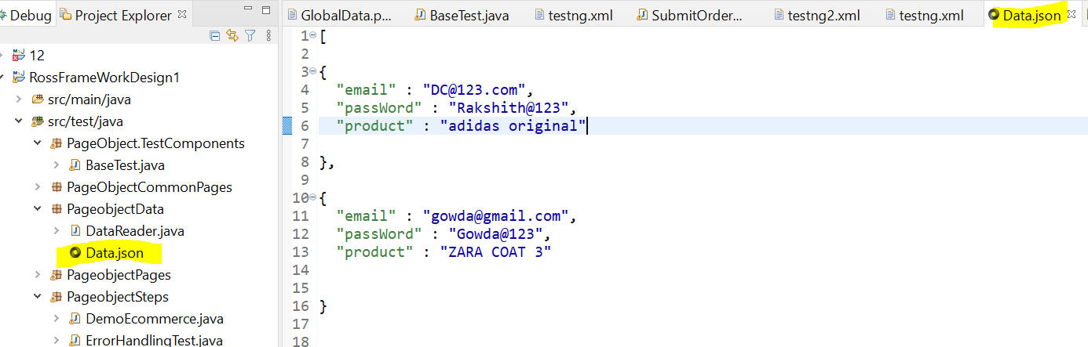

1. Read the json data , write code in baseclass

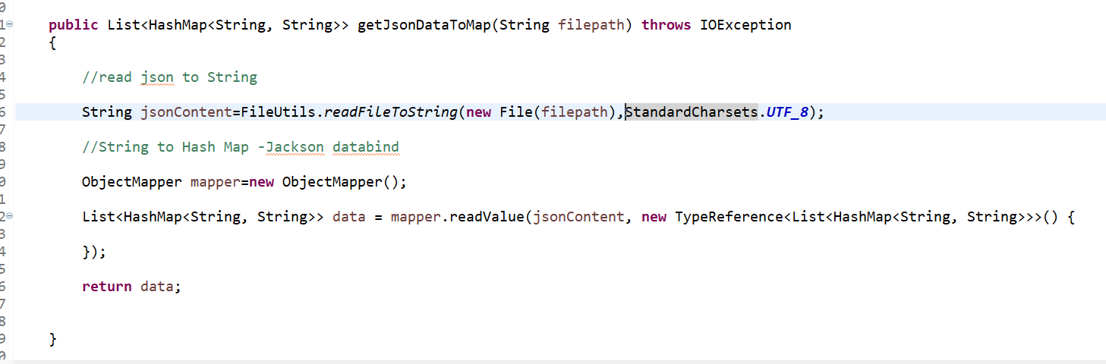

1. Call the generic method in the test case, with dataprovider annotation

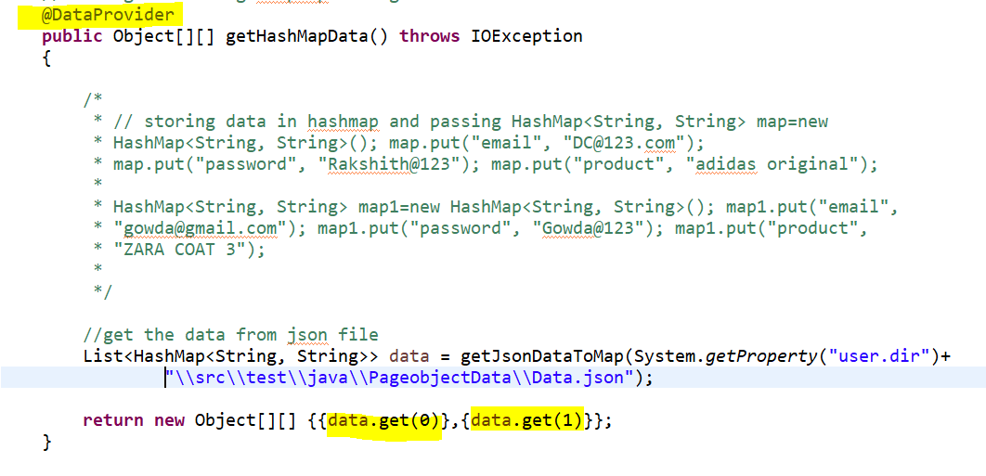

1. Send the data in the main test case

